**Introduction:**

**What is a Web Service? A:** It is a service provided over a Network, but this answer is not clearly understood or expressed**.** Virtually everything on the internet like, a Smartphone app or Databases can be thought of as a service provided via the Internet. However there is a difference between a web service and a web site.

A website can be thought of as a communication between humans, Where the contents are in such a way that each human can read and understand it.

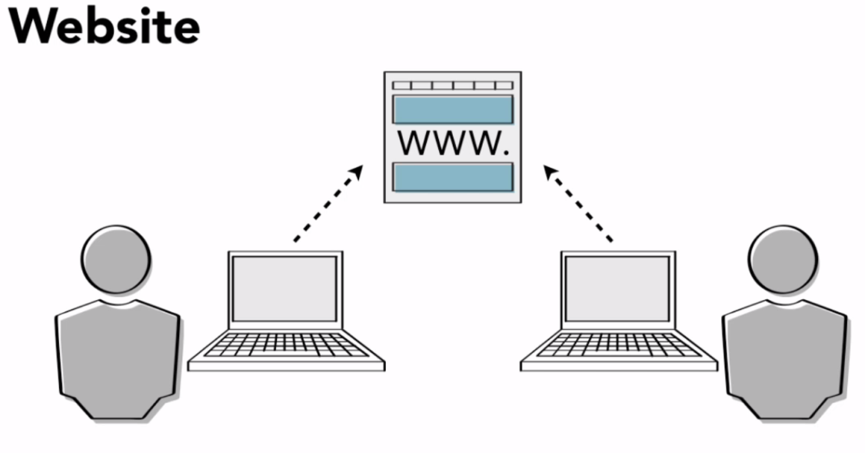

A Web Service on the other hand is the communication between two computers (or Web Applications). It helps two computers (or Web Application) to transfer data with each other. Often without any human intervention. Computers can use web Services to communicate with one another at low level. So, we can say that the web service is the backend part of the World Wide Web.

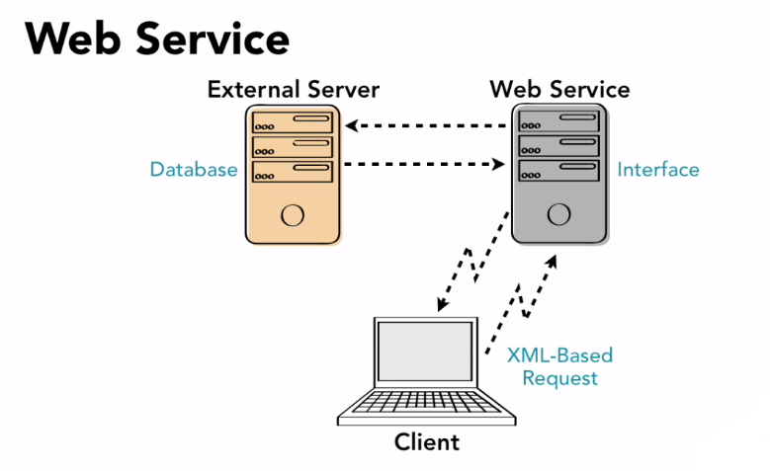

**Why Web Services? A:** The internet is consist of billions of different computers interacting with each other through a variety of different protocols and functions, and there is no guarantee that any two web application are (or program) that need to interact are written in the same language.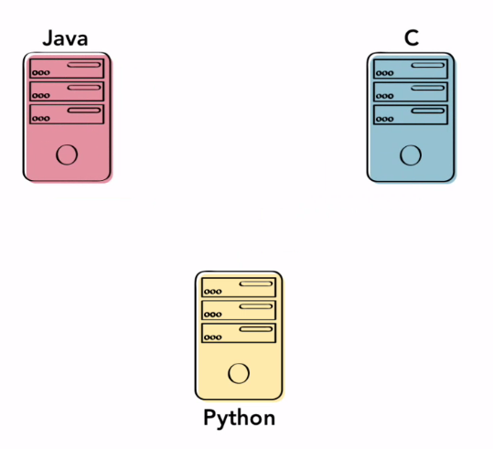

To solve this problem: **Web Services** bridge this gap by providing compatibility across multiple **languages** and **operating system**. A Web Service provides a set of standard information in a universally readable format (XML or JSON). Using this format it’s easy to transmit all the information required to use a program in a format understandable by any computer.